Appendix C: IEEE 830 Template
Software Requirements Specification
for
Pet Care System
Version 1.1
Prepared by SILVIA ARGÜELLO PINNA
Lodz University of Technology
17/03/2016
«Page Break»
Table of Contents
- Introduction
1.1 Purpose
1.2 Document Conventions
1.3 Intended Audience and Reading Suggestions
1.4 Product Scope
1.5 References
- Overall Description
2.1 Product Perspective
2.2 Product Features
2.2.1 Class Diagram
2.2.2 Sequence Diagram
2.3 User Classes and Characteristics
2.4 Operating Environment
2.5 Design and Implementation Constraints
2.6 User Documentation
2.7 Assumptions and Dependencies
- System Features
3.1 Use Case Diagram
3.2 Overview of Features
- External Interface Requirements
4.1 User Interfaces Overview
4.2 Hardware Interfaces
4.3 Software Interfaces
- System Features / Modules
5.1 Pet Management
5.2 Appointment Management
5.3 Medical Record Management
5.4 Reminder System
- Nonfunctional Requirements
6.1 Performance
6.2 Security

Revision History
Name | Date | Reason for Changes | Version
Silvia Argüello | 31/03/2026 | Initial version | 1.0
Silvia Argüello | 10/04/2026 | Added UML diagrams and improvements | 1.1
«Page break»
1. Introduction
1.1. Purpose
This document specifies the software requirements for the Pet Care System, a simple application designed to help pet owners and veterinarians manage pet information, appointments, medical records, and treatment history.
1.2. Document Conventions
«Describe any standards or typographical conventions that were followed when writing this specification, such as fonts or highlighting that have special significance. For example, state whether priorities for higher-level requirements are assumed to be inherited by detailed requirements, or whether every requirement statement is to have its own priority.»
1.3. Intended Audience and Reading Suggestions
This document is intended for the course instructor, developers, testers, and anyone involved in the design and evaluation of the Pet Care System. Section 1 provides the introduction and overall purpose of the project. Section 2 gives a general description of the system and its users. Sections 3 and 5 describe the system features and detailed functional requirements. Section 4 explains the external interfaces, and Section 6 presents the nonfunctional requirements. Readers should begin with the introduction and overall description before moving to the detailed requirements.
1.4. Product Scope
The purpose of the Pet Care System is to provide a simple and organized platform for pet care management. The system helps pet owners keep track of their pets’ appointments and health information, while veterinarians can update medical records and treatments efficiently.
1.5. References
• IEEE 830 Software Requirements Specification Template, provided in the course materials.
• Lab 2: UML Use Case Diagrams, Lodz University of Technology. This document explains actors, use cases, <<include>>, <<extend>>, and system boundary rules.
• Lab 3: UML Class Diagrams, Lodz University of Technology. This document explains classes, attributes, methods, and relationships such as association, aggregation, composition, inheritance, and dependency.
2. Overall Description
2.1. Product Perspective
The Pet Care System is a new, self-contained software product intended for small veterinary clinics and pet owners. It is designed as a lightweight management system focused on essential pet care functions.
2.2. Product Features
The main features of the Pet Care System are:
- Pet registration and profile management
- Appointment booking and cancellation
- Viewing pet medical records
- Updating medical records by veterinarians
- Treatment and prescription management
- Appointment reminder notifications

2.2.1 Class Diagram

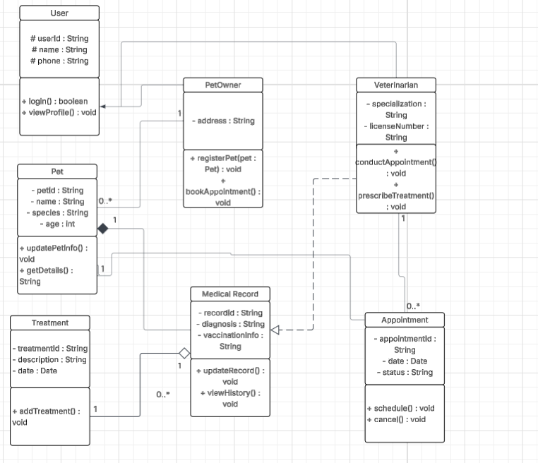
The Pet Care System class diagram includes several relationships between its main classes. PetOwner and Veterinarian inherit from User, meaning they share common attributes and basic functionalities (inheritance). A PetOwner is associated with one or more Pet objects, since each owner can register and manage multiple pets (association). Each Pet has exactly one MedicalRecord, which cannot exist without the pet, representing a strong whole-part relationship (composition). A Pet is also associated with multiple Appointment objects, as a pet can have several appointments over time (association). Similarly, a Veterinarian is associated with multiple Appointment objects, since one veterinarian can handle many appointments (association). The relationship between MedicalRecord and Treatment is an aggregation, meaning that a medical record can contain multiple treatment entries, but each treatment can exist independently (aggregation). Finally, Veterinarian has a dependency on MedicalRecord, as the veterinarian uses the medical record to access and update information during consultations, without owning it (dependency).2.3. User Classes and Characteristics
The main user classes are Pet Owner and Veterinarian. Pet Owners use the system occasionally to register pets, book appointments, and review pet information. Veterinarians use the system more frequently to conduct appointments and manage medical records.

2.2.2 Sequence Diagram

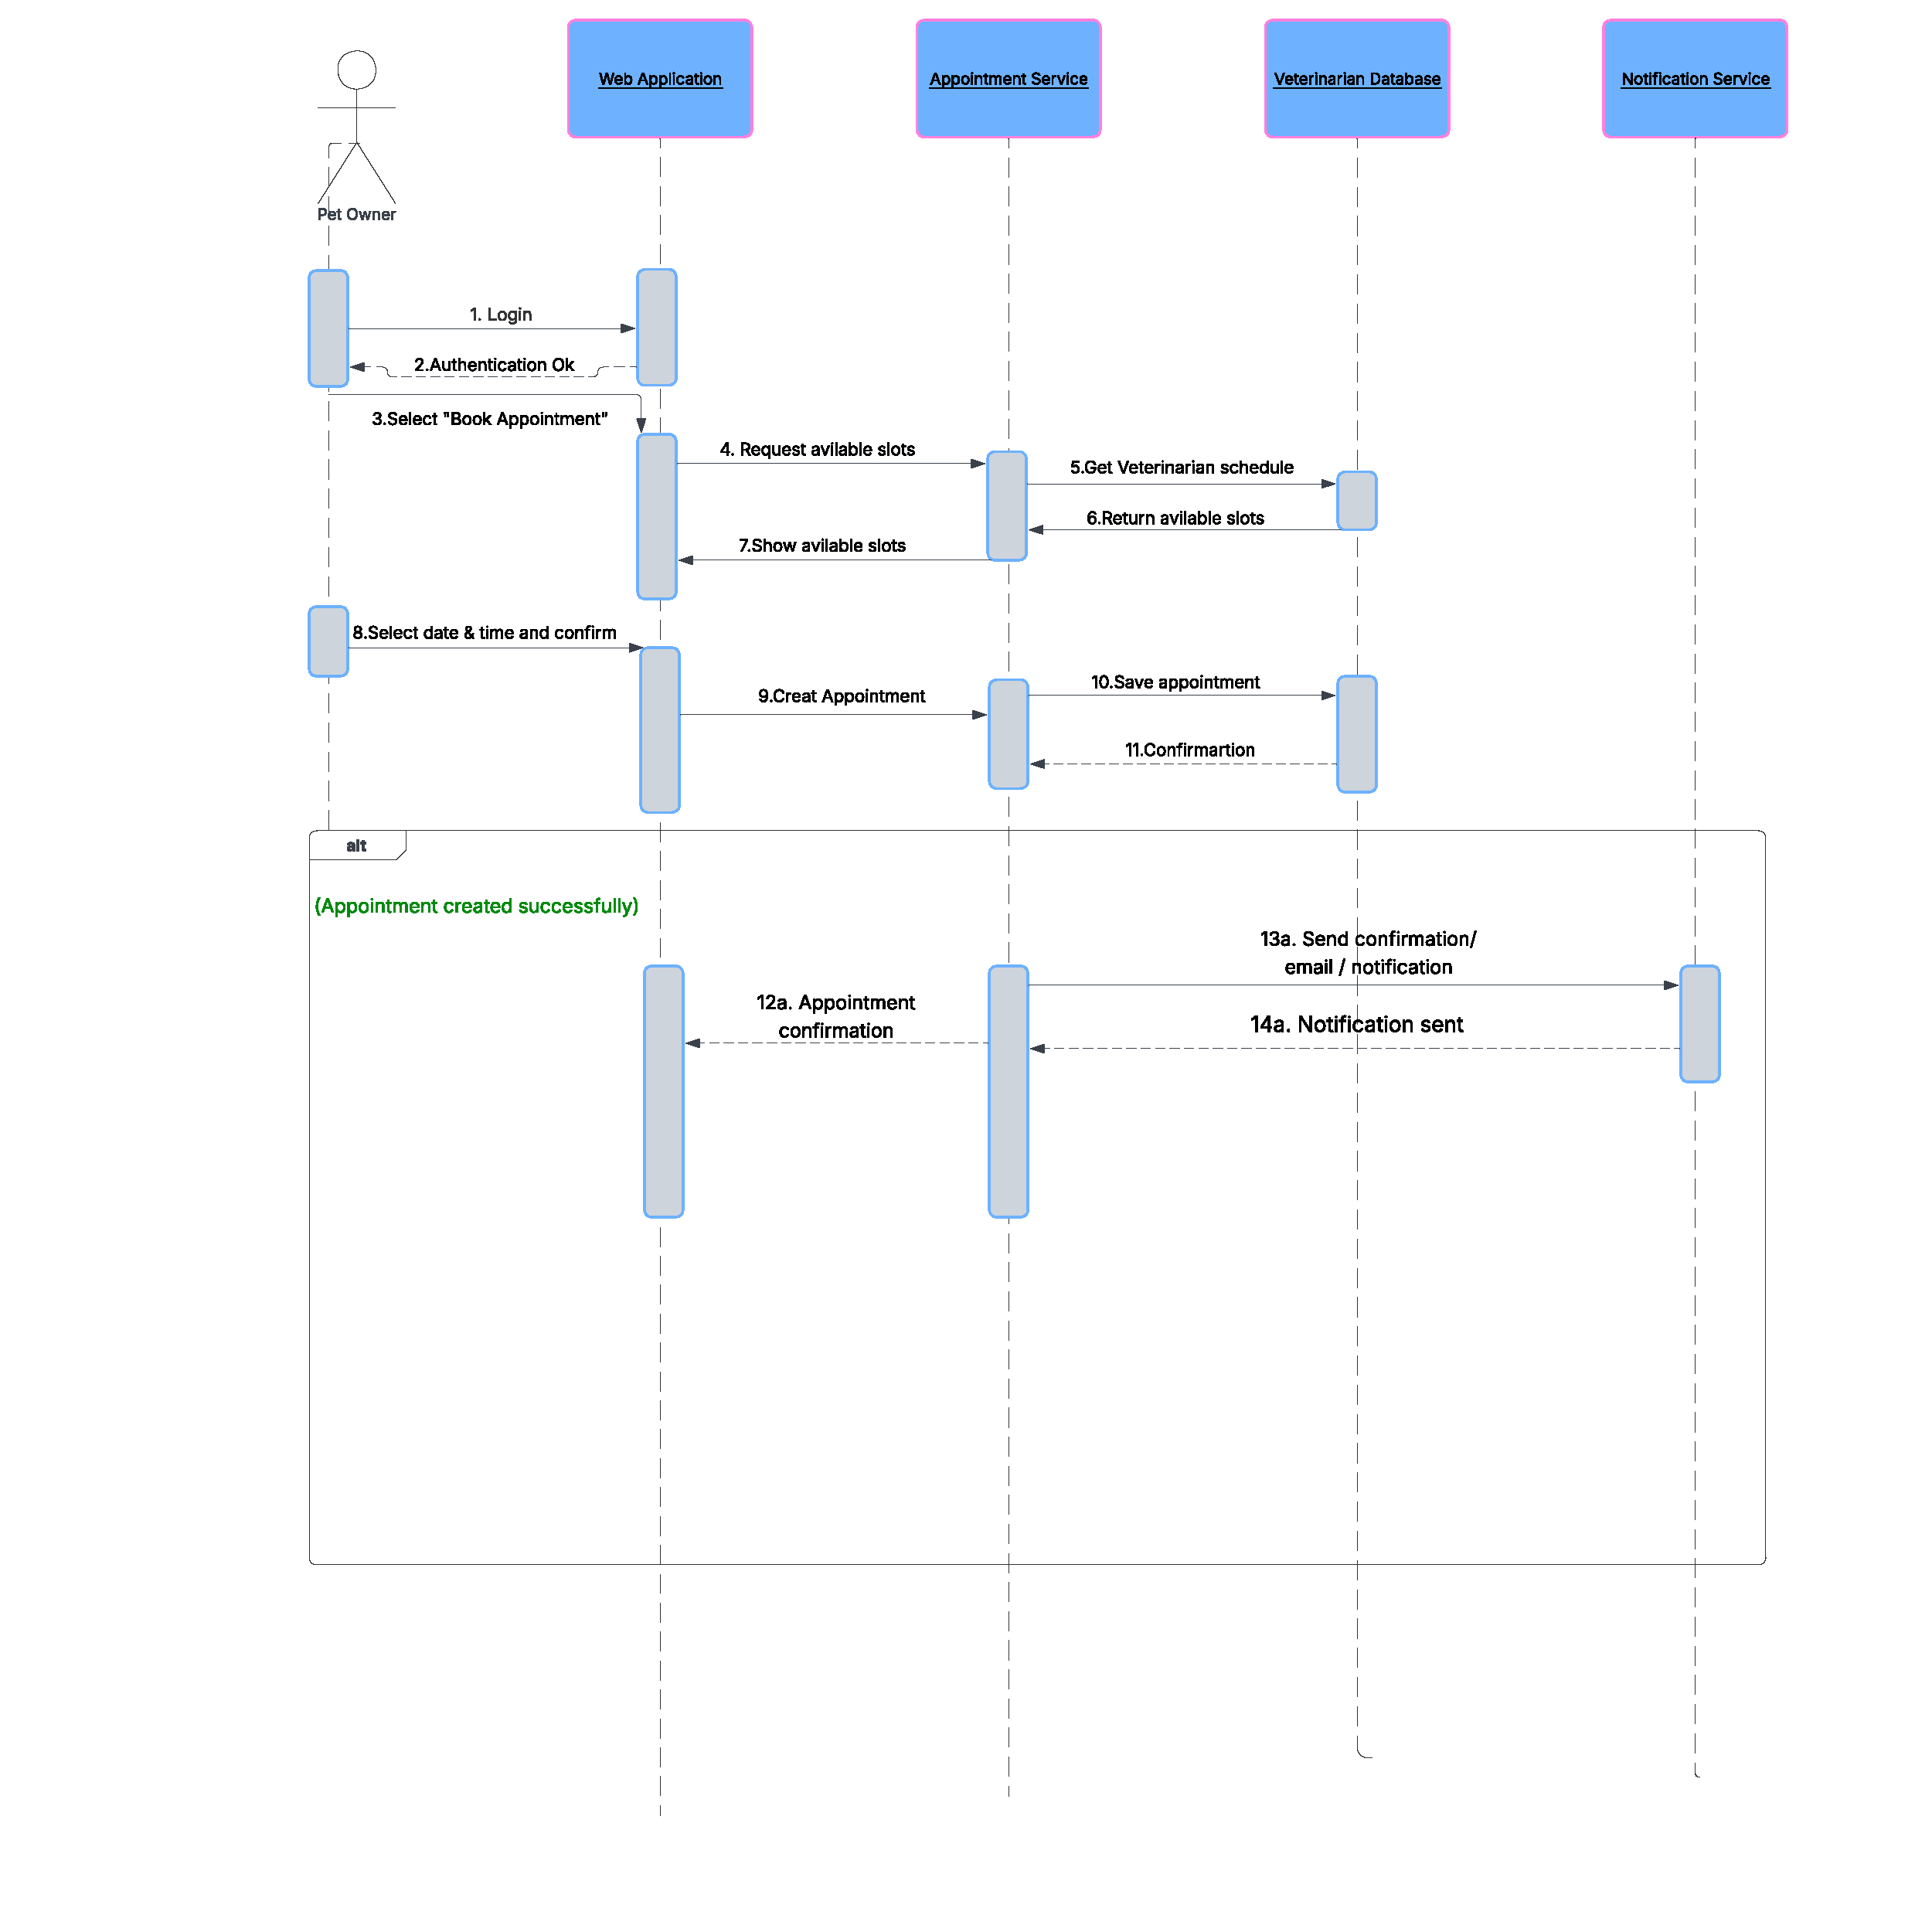
The sequence diagram shows how a Pet Owner books an appointment in the Pet Care System.
The process begins when the user logs in and selects a time slot. The system retrieves available slots, creates the appointment, and stores it in the database. Then, a confirmation is sent to the user.
An alternative flow («alt») is included to represent possible outcomes: either the appointment is successfully created or an error message is displayed if something goes wrong.

2.4. Operating Environment
The software will operate as a web-based desktop application accessible through modern web browsers such as Google Chrome, Mozilla Firefox, Microsoft Edge, and Safari. It is intended to run on personal computers and laptops using Windows and macOS. The system requires an Internet connection to access and update pet, appointment, and medical record data.
2.5. Design and Implementation Constraints
The system shall be designed as a simple academic project, so its scope will be limited to essential pet care management functions. The application will be developed as a web-based system for desktop use only. The interface should remain simple and easy to use for non-technical users. The project must follow UML modeling conventions discussed in class, including use case and class diagrams. Time and complexity constraints mean that advanced features such as payment processing, GPS tracking, or mobile support will not be included
.2.6. User Documentation
The system will include basic user documentation in the form of:
- a short user guide in PDF format,
- brief on-screen instructions,
- simple error and confirmation messages,
- a project report containing UML diagrams and system description.
2.7. Assumptions and Dependencies
«List any assumed factors (as opposed to known facts) that could affect the requirements stated in the specification. These could include third-party or commercial components that you plan to use, issues around the development or operating environment, or constraints. The project could be affected if these assumptions are incorrect, are not shared, or change. Also identify any dependencies the project has on external factors, such as software components that you intend to reuse from another project, unless they are already documented elsewhere (for example, in the vision and scope document or the project plan).»

3. System Features
3.1
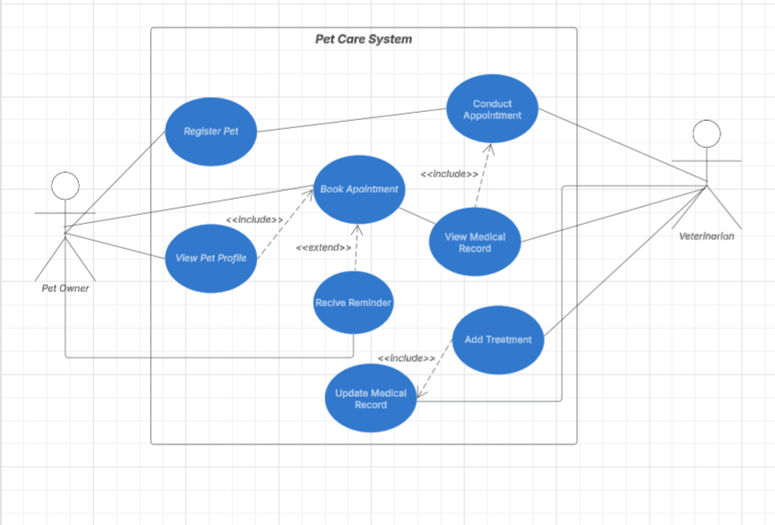
The Use Case Diagram shows the main functionalities of the Pet Care System and how the two actors, Pet Owner and Veterinarian, interact with it.
The Pet Owner manages pets, appointments, and views information, while the Veterinarian conducts appointments and updates medical records.
The <<include>> relationships represent mandatory actions (e.g., booking an appointment requires viewing the pet profile), while the <<extend>> relationship shows optional behavior such as receiving reminders.
3.2 Pet Management
This feature allows Pet Owners to register and manage their pets within the system. Users can create, view, and update pet profiles, including basic information such as name, age, and type.
3.3 Appointment Management
This feature enables Pet Owners to book appointments and allows Veterinarians to conduct them. The system manages available time slots, appointment scheduling, and confirmation.
3.4 Medical Record Management
This feature allows Veterinarians to create and update medical records for each pet. Pet Owners can view these records, while Veterinarians can add treatments and update health information.
3.5 Reminder System
This feature provides notifications to Pet Owners about upcoming appointments. Reminders are optional and help users keep track of scheduled visits.
4. External Interface Requirements
4.1. User Interfaces Overview
The Pet Care System will provide a graphical user interface (GUI) accessible through a web browser. Users will interact with the system using standard elements such as buttons, forms, and navigation menus.
Pet Owners will be able to:
- Register and log in
- Add and manage pets
- Book and view appointments
- Access medical records
Veterinarians will be able to:
- View scheduled appointments
- Conduct appointments
- Update medical records and treatments
The system will provide clear feedback through:
- Confirmation messages (e.g., appointment successfully booked)
- Error messages (e.g., invalid input or unavailable time slot)
The interface will follow a simple and intuitive layout, ensuring ease of use for non-technical users. Each screen will include basic navigation options such as “Home”, “Back”, and “Logout”.

4.2. Hardware Interfaces
«Describe the logical and physical characteristics of each interface between the software product and the hardware components of the system. This may include the supported device types, the nature of the data and control interactions between the software and the hardware, and communication protocols to be used.»
4.3. Software Interfaces
«Describe the connections between this product and other specific software components (name and version), including databases, interpreters, operating systems, tools, libraries, and integrated commercial components. Identify the data items or messages coming into the system and going out and describe the purpose of each. Describe the services needed and the nature of communications. Identify data that will be shared across software components. If the data sharing mechanism must be implemented in a specific way (for example, use of a global data area in a multitasking operating system), specify this as an implementation constraint.»
5. System Features/Modules
«This template illustrates organizing the functional requirements for the product by system features, the major services provided by the product.»
5.1. «System Feature Name»
5.1.1 Description and Priority
«Provide a short description of the feature. Give its priority, too.»
5.1.2 Stimulus/Response Sequences
«”Stimulus” or “Condition”»: «Describe the stimulus or condition»
Response: «Describe the response»
«Additional Stimulus/Response pairs as needed»
5.1.3 Functional Requirements
«Itemize the detailed functional requirements associated with this feature. These are the software capabilities that must be present in order for the user to carry out the services provided by the feature. Include how the product should respond to anticipated error conditions or invalid inputs. Requirements should be concise, complete, unambiguous, verifiable, and necessary. Each requirement should be uniquely identified with a sequence number or a meaningful tag of some kind.»
REQ-1.1: «Some sentence goes here, in “shall” form, usually something like this: “Upon <some event or condition>, the <system, or the name of a module> shall <perform some action>.” Note that the entire requirement must be stated in the requirements area. Everything else is just a lead-up to this. There should be one such entry per S/R pair.»
REQ-1.«N»: «Additional S/R-related requirements as needed.»
REQ-1.«N»: «List any additional requirements needed in “Shall” form, but not necessarily in “Upon/Shall” form.»
REQ-1.«N»: «Additional requirements as needed.»
5.«N». «Additional feature blocks»
6. Nonfunctional Requirements
6.1. Performance
NF-1.1: «Any performance-related issue»
NF-1.«N»: «Any performance-related issue»
6.2. Security
NF-2.1: «Any security-related issue»
NF-2.«N»: «Any security-related issue»
6.«N». «Any additional “nonfunctional” blocks»

